

**Removing infrastructure to restore tidal marsh to the Mastic Beach coastline**

**National Fish and Wildlife Foundation National Coastal Resilience Fund 2019**

Pre-Restoration Monitoring

2021 Summary (Updated January 26, 2022)

**PROJECT SUMMARY**

This project will remove two segments (2,590 linear feet) of existing roadway in Mastic Beach, NY and restore the area to native coastal marsh habitat. Restoration will be completed by planting area-appropriate marsh grasses and monitoring the impact of restoration efforts on birds and vegetation. Road segments located near Sheepen Creek and West of Cranberry are both within the 2018 NFWF grant project area; Riviera Drive East is immediately east of the larger project area, located on the east bank of Pattersquash Creek, but was removed from the initial phase of this project due to an invasive species issue (Phragmites).

**METHODS**

In 2021, pre-restoration monitoring was conducted to determine current conditions and establish a baseline which can be used to quantify changes to the site that result from restoration activities. The assessment of current conditions was conducted using a two-part approach. First, Saltmarsh Habitat and Avian Research Program (SHARP) protocol was used to detect the presence, distribution and density of marsh birds, and the structure and diversity of vegetation in the broader restoration area. Second, vegetation quadrats were conducted on, and immediately adjacent to, the road to be restored to quantify the progress of the road removal and revegetation. Ten SHARP survey points and 27 vegetation quadrats were established within the project site (Figures 1 & 4).

**Saltmarsh Habitat and Avian Research Program (SHARP)**

*Avian Point-Count/Callback Surveys*

Avian point-count and callback surveys were conducted during the breeding season on June 17th and 30th, 2021. Ten points were randomly distributed throughout the greater project area (Figure 2). At each point, a speaker was used to broadcast a pre-recorded playback. The first five minutes of the playback were of silence, (no calls broadcast) at which time the observer recorded the number of individuals of each species seen or heard using the habitat within approximately 100m. The passive period was followed by a period of playback where the calls of secretive marsh species (Black Rail, Least Bittern, Sora, Virginia Rail, King Rail, Clapper Rail, and Common Gallinule) were broadcast in 30 second intervals followed by 30 seconds of silence. During the callback period, the observer recorded any additional species that were seen or heard within the survey area.

*Vegetation Surveys*

The vegetation component of the survey consists of a 50m-radius plot centered on the same point used for the point-count survey (Figure 3). In this plot, the percent cover of each community type present is estimated using the following cover classes: 0%, <1%, 1-5%, 6-10%, 11-25%, 26-50%, 51-75%, and 76-100%. Community types estimated using cover classes include low marsh, high marsh, salt marsh terrestrial border, brackish terrestrial border, invasives, pannes, open water, upland, wrack, and snags. In addition, the percent cover of dominant species within the plot (those covering more than 5%), was estimated to the nearest 5%. The vegetation plot is bisected by a 100m transect that runs toward the upland and water, along the wetland elevation gradient (Figure 1). Ten vegetation samples were taken along this transect at specific intervals (0, 11, 22, 33, 45, 56, 67, 78, 89, and 100m; Figure 2). At each sample point, a thin rod was inserted into the soil 50cm to the left of the transect. Each species that touched the rod was recorded, including whether conditions such as standing water, rock, wrack, bare ground, or algae were present.

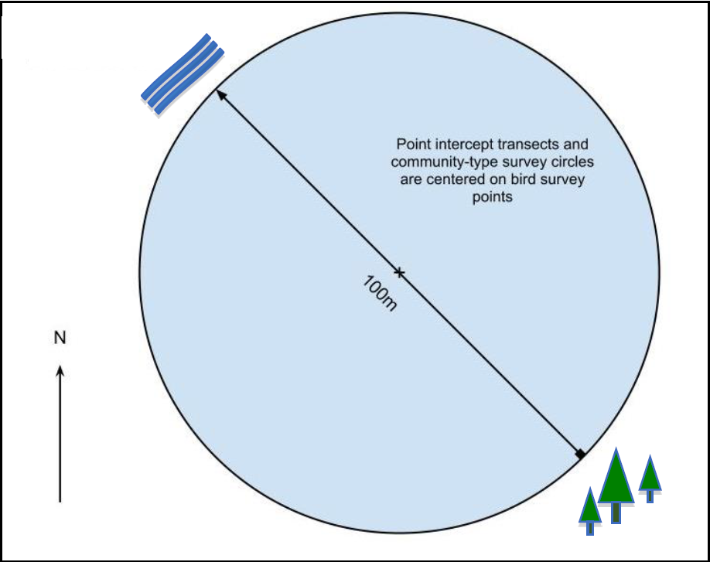

Figure 1. A diagram of the SHARP vegetation survey plot and transect.

Figure 2. Schematic demonstrating how to measure vegetation along point intercept transects.

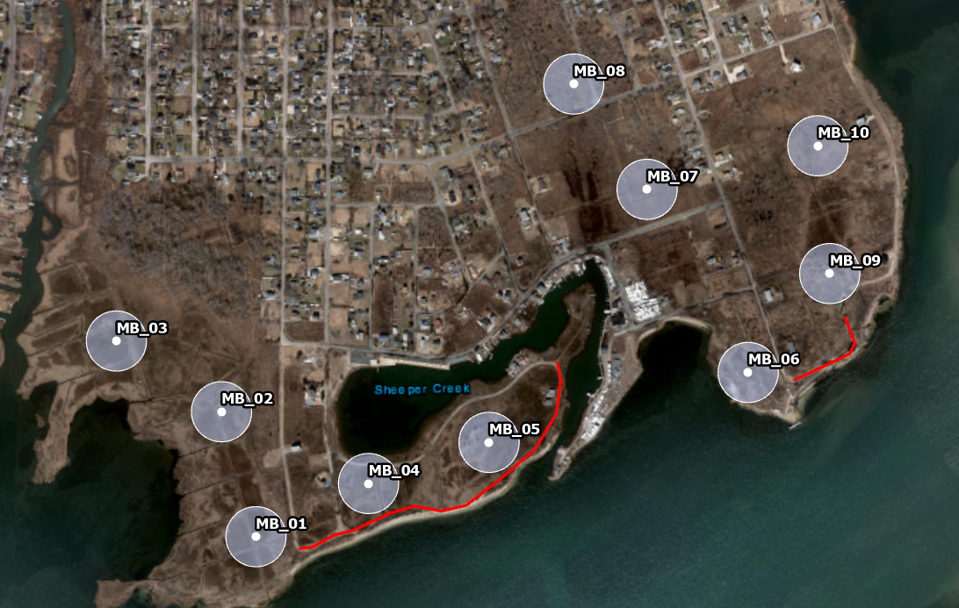

Figure 3. SHARP survey points. Points represent the location from which point-count surveys were conducted, which coincide with the center of the survey plot and transect. Transparent buffers represent the survey plot where the percent cover of habitat types and dominant species are estimated (50m radius plots). Red lines indicate the road restoration area.

**CURRENT CONDITIONS**

**Saltmarsh Habitat and Avian Research Program (SHARP)**

*Avian Point-Count/Callback Surveys*

In total, 34 unique bird species were observed across both visits (Table 1). Saltmarsh Sparrows were observed in surprisingly high numbers at both visits. Saltmarsh Sparrows were in the highest abundance at points 6 and 9, and lower abundances in the southeast portion of the project area (points 1 – 5). Saltmarsh Sparrows were never observed at points 7 and 8, which may be due to extremely dense Phragmites and poison ivy that make the habitat inhospitable for the Saltmarsh Sparrow.

Table 1. A list of all species observed during the two SHARP survey visits.

|  |  |  |  |  |
| --- | --- | --- | --- | --- |
| **Common Name** | **Latin Name** | **Alpha Code** | **Number Seen Visit 1** | **Number Seen Visit 2** |
| American Oystercatcher | *Haematopus palliatus* | AMOY | 2 | 0 |
| Barn Swallow | *Hirundo rustica* | BARS | 8 | 11 |
| Boat-tailed Grackle | *Quiscalus major* | BTGR | 0 | 1 |
| Carolina Wren | *Thryothorus ludovicianus* | CARW | 1 | 0 |
| Clapper Rail | *Rallus longirostris* | CLRA | 5 | 4 |
| Common Grackle | *Quiscalus quiscula* | COGR | 3 | 3 |
| Common Yellowthroat | *Geothlypis trichas* | COYE | 3 | 4 |
| Double-crested Cormorant | *Phalacrocorax auritus* | DCCO | 1 | 0 |
| European Starling | *Sturnus vulgaris* | EUST | 1 | 2 |
| Fish Crow | *Corvus ossifragus* | FICR | 1 | 0 |
| Glossy Ibis | *Plegadis falcinellus* | GLIB | 1 | 5 |
| Gray Catbird | *Dumetella carolinensis* | GRCA | 2 | 1 |
| Great Black-backed Gull | *Larus marinus* | GBBG | 3 | 0 |
| Great Egret | *Ardea alba* | GREG | 4 | 1 |
| Green Heron | *Butorides virescens* | GRHE | 0 | 1 |
| Herring Gull | *Larus argentatus* | HERG | 6 | 6 |
| House Sparrow | *Passer domesticus* | HOSP | 2 | 0 |
| Little Blue Heron | *Egretta caerulea* | LBHE | 0 | 1 |
| Mallard | *Anas platyrhynchos* | MALL | 1 | 0 |
| Mourning Dove | *Zenaida macroura* | MODO | 6 | 6 |
| Mute Swan | *Cygnus olor* | MUSW | 2 | 0 |
| Northern Cardinal | *Cardinalis cardinalis* | NOCA | 1 | 0 |
| Northern Mockingbird | *Mimus polyglottos* | NOMO | 1 | 0 |
| Osprey | *Pandion haliaetus* | OSPR | 12 | 9 |
| Red-winged Blackbird | *Agelaius phoeniceus* | RWBL | 64 | 42 |
| Saltmarsh Sparrow | *Ammodramus caudacuta* | SALS | 17 | 19 |
| Seaside Sparrow | *Ammodramus maritima* | SESP | 5 | 5 |
| Snowy Egret | *Egretta thula* | SNEG | 0 | 16 |
| Song Sparrow | *Melospiza melodia* | SOSP | 9 | 7 |
| Tree Swallow | *Tachycineta bicolor* | TRES | 13 | 8 |
| Unidentified Yellowlegs | *Tringa melanoleuca or*  *T. flavipes* | UNYE | 0 | 4 |
| Willet | *Tringa semipalmata* | WILL | 30 | 24 |
| Willow Flycatcher | *Empidonax traillii* | WIFL | 4 | 3 |
| Yellow Warbler | *Setophaga petechia* | YEWA | 2 | 0 |

Figure 5. The number of Saltmarsh Sparrows observed at each SHARP survey plot across both visits.

*Vegetation Surveys*

The most common habitat type recorded in the SHARP surveys was high marsh, which was the dominant habitat type (>50% cover) at 7 of the 10 survey points. Two points contained high marsh but in < 50% cover. Point 8 was dropped from the surveys because Phragmites and poison ivy made navigation to the point impossible. All plots had approximately 5% cover of pannes and creeks. Invasive species cover was found in all plots. Only two plots had invasive cover > 25%, while the remaining plots each had less than 10% cover of invasives. The most common species in the survey plots was *Spartina alterniflora*, which averaged 20% cover in each plot. The next most common species were *Spartina patens* and *Phragmites australis*, which were both averaged 16% cover in plots. All other species identified had < 10% cover.