The dataset prepared by Vida Marina – UPR Aguadilla provides beach elevation data collected at several sites along the north coast of Puerto Rico. Data were collected by an operator using an unmanned aerial vehicle for surveying the site and obtaining elevation data (XYZ) along preselected transects. The horizontal position (longitude and latitude) data are given in the Universal Transverse Mercator (UTM) projected coordinate system referenced to the North American Datum of 1983 (NAD83). Puerto Rico is split into two UTM zones, 19 and 20 (Figure 1). The transition seems to occur, as referenced, close to the municipality of Carolina (UTM: 20 Q 183149.00 m E 2044329.00 m N). The elevation data are referenced to the North American Vertical Datum of 1988 (NAV88).

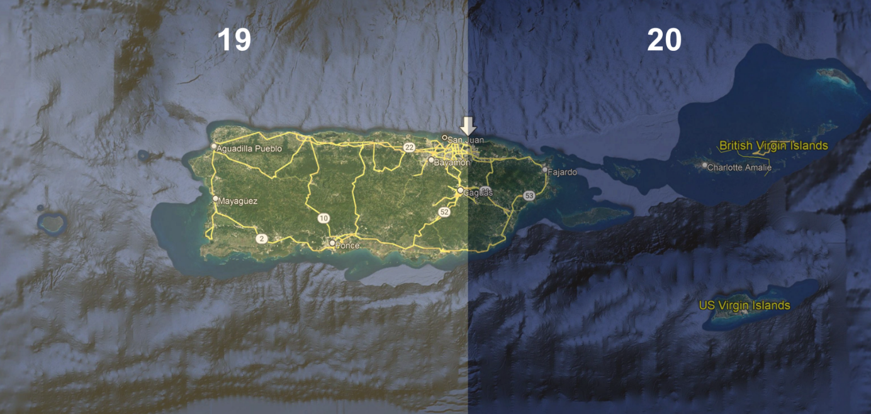
Figure 1 UTM zones for Puerto Rico and US Virgin Islands

