Assessment of Active Sand Volumes at Rockaway Peninsula and Fire Island in New York and Seven Mile Island in New Jersey (in press) DRAFT

By Noreen A. Buster,¹ Jennifer L. Miselis,¹ Emily A. Wei,² and Arnell S. Forde¹
¹ U.S. Geological Survey St. Petersburg Coastal and Marine Science Center
² Louisiana State University, Department of Geology and Geophysics
Contact for questions: Jennifer Miselis, jmiselis@usgs.gov

Between 2018 and 2023, the U.S. Geological Survey (USGS) assessed shoreface sediment availability at three Atlantic Coast barrier island sites in support of a National Fish and Wildlife Foundation (NFWF) project entitled “Monitoring Hurricane Sandy Beach and Marsh Resilience in New York and New Jersey.” The three study sites include Seven Mile Island, New Jersey (NJ), Rockaway Peninsula, New York (NY), and Fire Island, NY (Figure 1). Previously interpreted geologic boundaries from shoreface geophysical surveys and data from repeat bathymetric surveys at each of the study sites were integrated to quantify the active sediment volume, or the volume of sediment that could contribute to beach and shoreline behavior over annual to decadal time scales. The seaward extent of active sediment volume for this study was the depth of closure (DoC) as calculated from wave conditions at each study site. A full report describing in detail the methods used to calculate these volumes and the variability of active sediment volume for each survey at the three study sites can be provided upon request. In the interest of providing the best available science in a timely fashion, this summary document and volume data are provisionally provided while the accompanying full report is still in press at the U.S. Geological Survey publishing service.
To account for short-term changes, this report refines the estimate of “active sand volume” from a purely geologic definition by using interannual bathymetry surveys and an estimate of the DoC (Hallermeier, 1981) as the upper and offshore volume boundaries, respectively. To do this, we 1) identified interpreted geologic boundaries (Wei and others, in press; Wei and others, 2021; Wei and Miselis, 2022; Locker and others, 2017) that represent the base boundary of sandy shoreface sediments, 2) subtracted the base surface from time-varying seafloor surfaces derived from repeat seafloor high-resolution MBES or SBES surveys, 3) identified the seaward limit of sediment movement, or the DoC, for each seafloor survey, and 4) calculated the volume of sediment between the base geology, the seafloor, and the DoC for each time period at each study site. Active sand volumes at each of the three study sites were computed within Global Mapper v.25.0 using the tool “Measure Volume Between Two Surfaces”. The surface of the base of the active sand boundary was compared with each of the three bathymetric DEM surfaces at each site, totaling nine volume calculations. The tool ingests the two surfaces, clips to the appropriate extents, and calculates volume in cubic meters (m³) as well as spatial area in square meters (m²) within which the volume change occurred.
The data are provided in the table below, and include the total active sand volume (Table 1, column 2), change area (Table 1, column 3), volumes normalized by shoreline extent (Table 1, column 4), the percent volume uncertainty associated with acquisition, gridding, and calculations (Table 1, column 5), the uncertainty volume (Table 1, column 6), and by how much the average annual volume changes exceed that volume (Table 1, column 7) all of which are described more completely in the full report text that is in press.

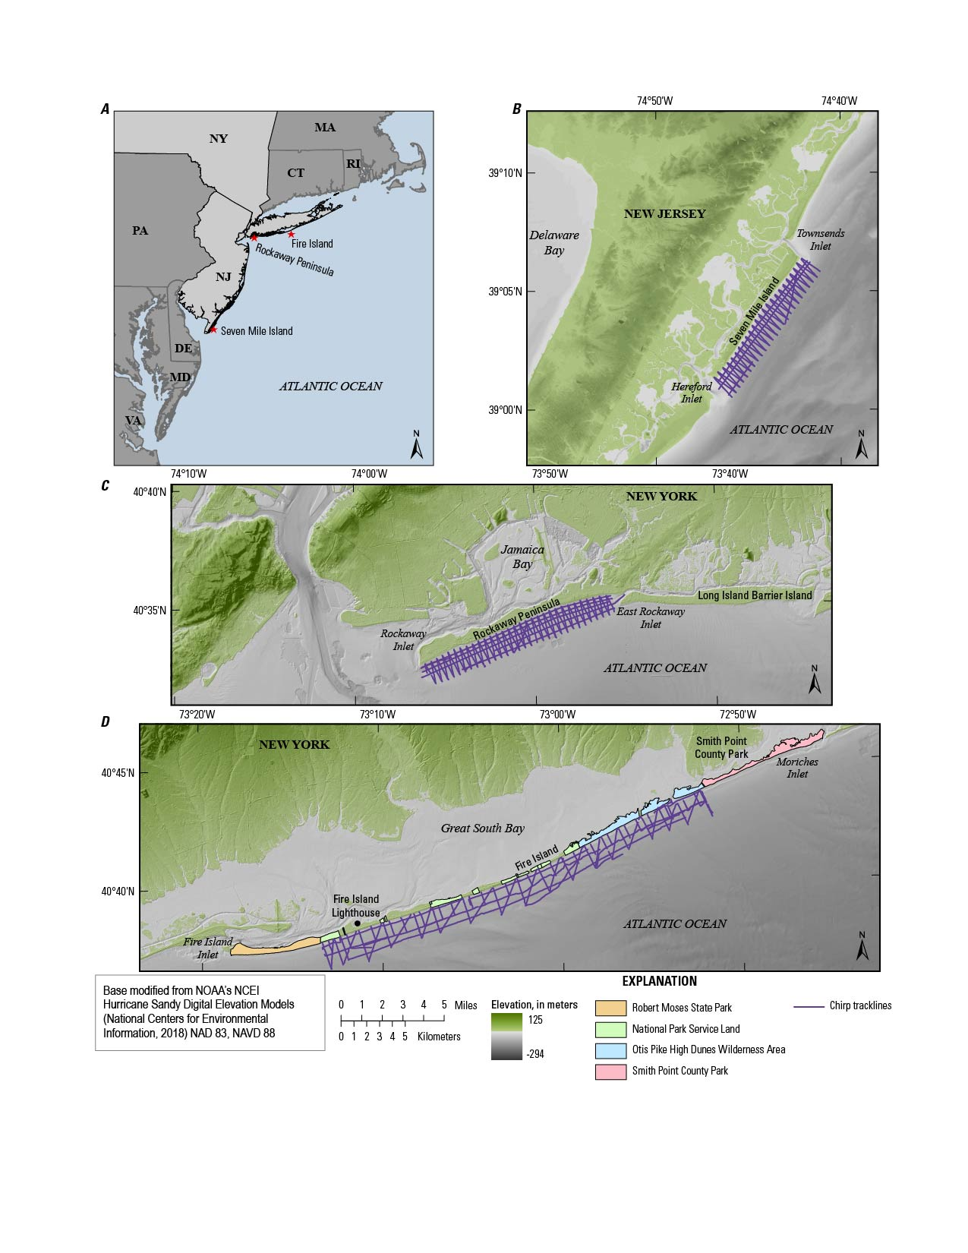
Figure 1. Index and location maps of the three survey sites discussed in this report, with chirp profile tracklines shown in purple. A) Regional index map with red stars and labels indicating locations of study sites. B) Seven Mile Island, NJ, C) Rockaway Peninsula, NY, and D) Fire Island, NY, study sites.

Table 1. Summary of active sand volumes, associated uncertainties, and volume change uncertainty exceedance values.
Site  Year | Total Active Sand Volume (TASV) (m³) |  | Change  Area  (m²) | Normalized Volume  (m³/m²) |  | Volumetric Uncertainty  (NSU_{volume})  (%) | Volume  Uncertainty  (VU)  (m³) | Volume Change Uncertainty Exceedance
Seven Mile
Island
2018 | 36,123,467 | 11,317,000 |  |  | 3.19 | 2.15 | 775,870
2021 | 34,207,816 | 11,084,000 |  |  | 3.09 | 2.06 | 703,928 | 2.6
2023 | 35,322,956 | 11,209,000 |  |  | 3.15 | 2.02 | 713,302 | 1.6
Averages | 35,218,080  (± 962,122) | 11,203,333 |  |  | 3.14 | 2.08 | 731,034
Rockaway
Peninsula
2019 | 40,511,732 | 12,935,400 |  |  | 3.13 | 1.53 | 620,029
2021 | 42,253,210 | 13,128,600 |  |  | 3.22 | 1.60 | 677,811 | 2.7
2023 | 41,909,771 | 13,058,100 |  |  | 3.21 | 1.44 | 602,708 | 0.5
Averages | 41,558,238  (± 922,425) | 13,040,700 |  |  | 3.19 | 1.52 | 633,516
Fire Island
2014 | 42,348,488 | 19,324,000 |  |  | 2.19 | 1.90 | 804,068
2015 | 39,762,766 | 19,388,000 |  |  | 2.05 | 1.95 | 774,183 | 3.3
2018 | 42,003,251 | 19,583,000 |  |  | 2.14 | 2.03 | 851,052 | 2.8
Averages | 41,371,502  (± 1,403,859) | 19,431,667 |  |  | 2.13 | 1.96 | 809,918

Locker, S.D., Miselis, J.L., Buster, N.A., Hapke, C.J., Wadman, H.M., McNinch, J.E., Forde, A.S., and Stalk, C.A., 2017, Nearshore sediment thickness, Fire Island, New York: U.S. Geological Survey Open-File Report 2017–1024, 21 p., https://doi.org/10.3133/ofr20171024.

Wei, E.A., Miselis, J.L., Buster, N.A., and Forde, A.S., in press, 2024, Geologic Framework and Holocene sand thickness offshore of Seven Mile Island, New Jersey: U.S. Geological Survey Scientific Investigations Report.
Wei, E.; Miselis, J., 2022, Geologic Framework, Anthropogenic Impacts, and Hydrodynamics Contribute to Variable Sediment Availability and Shoreface Morphology at the Rockaway Peninsula, NY. Journal of Marine Science and Engineering, 10(7), 989, https://doi.org/10.3390/jmse10070989.
Wei, E.A., Miselis, J.L., and Forde, A.S., 2021, Shoreface and Holocene sediment thickness offshore of Rockaway Peninsula, New York: U.S. Geological Survey Open-File Report 2021–1100, 14 p., https://doi.org/10.3133/ofr20211100.

